**Research on China’s Sludge Production Pattern, Prediction and Carbon Emission Reduction Potential**

**ABSTRACT:** China has the world’s largest wastewater treatment capacity, but the rapid increase in sludge production, insufficient disposal capacity, and low level of resource utilization pose a challenge to China’s solid waste management. Resource recovery of sludge is an important tool to promote the sustainable development of the wastewater treatment industry. Predicting the spatial and temporal trends of sludge generation is conducive to regional planning of sludge treatment and disposal capacity, evaluating the potential of sludge carbon emissions. We used data from 3495 wastewater treatment plants to screen sludge driving factors by Geodetector. Training a random forest regression model to predict the future sludge production and its carbon emission potential in China’s provincial-level under different shared socioeconomic pathways. The results show that urban form, economic development, urbanization level, and food consumption are the main reasons affecting sludge production. By 2060, sludge production will continue its upward trend but with decreasing growth rate. The production in SSP1 to SSP5 scenarios will reach 1.95, 2.05, 2.31, 2.20, 2.41 times of 2017 respectively. The clustering analysis classified Chinese sludge growth patterns into four categories: high-value high growth, high-value low growth, low-value high growth, and low-value low growth, and the differentiated strategies helped to reduce carbon emissions from sludge disposal. The prevalence of anaerobic digestion at 44%, 84%, 96%, and 99%, respectively, will not increase sludge carbon emissions compared to 2020. Increasing the share of sludge Land application also significantly reduces sludge carbon emissions. Combining anaerobic digestion and low carbon disposal methods on sludge can reduce 44.38 to 52.91 Mt CO2 emission every year in the middle of this century.

**KEYWORDS:** Sludge, Carbon emission, Factor detector, Machine learning, Shared socioeconomic pathways (SSPs)

**HIGHLIGHTS:**

* ML model forecasts sludge generation and its GHG emissions growth.
* SSP1 has the lowest sludge generation while SSP5 has the most.
* There are four patterns of sludge growth in China
* Midwest provinces have higher sludge growth rate.
* Anaerobic digestion and low carbon disposal methods can reduce 75% GHG emission.

# Introduction

Urban wastewater treatment is a great energy-consuming sector, accounting for about 3% of global power consumption and 1.75% greenhouse gas (GHG) emissions (McCarty et al., 2011). The Chinese government is actively seeking to make a paradigm shift, and recovery of sludge will be the key to promoting the sustainable development of the entire wastewater treatment industry (Lu et al., 2018). In 2017, China’s urban wastewater treatment plants produced about 10.49 Mts dry sludge, which was about 1.5-fold than European Union (Eurostat., 2020). Sludge growth in China after 2010 was about 10% annually, which was higher than the growth of GDP (MOHURD., 2019). Collecting sub-level data to identify sludge growth in different regions is an important method to calculate the potential of GHG emissions of sludge treatment and disposal, and it can develop laws to regulate sludge management. However, there are few quantitative studies on the future growth of sludge and its GHG emissions in China. Data of different researches varied significantly and has limited resolution, lacking statistics of sludge at the city level.

The generation of sludge in cities is a macro and complex process, influenced by multiple factors such as economic progress (Duarte et al., 2014; Kangkang et al., 2009), social development (Xu et al., 2019), industrial structure (Lili et al., 2019; Tiziano et al., 2018), treatment technology (Jin et al., 2014) ，residents' lifestyles (Xiao et al., 2020) and so on. Due to the vast area of China and the spatial heterogeneity in population and economic development between regions, exploring the driving factors can allow for targeted sludge management policies. However, existing studies have mostly explored the factors influencing sludge production in one aspect (Yu et al., 2007), such as economics and technology, and the spatial heterogeneity of sludge generation in China has been less explored and cannot reflect the spatial differences in sludge generation with higher accuracy. Therefore, this paper used national-wide plant-level data to reveal the driving factors of sludge generation by Geodetector modeling in China. Geodetector is a set of statistical methods that reveal the spatially stratified heterogeneity of features and explore the driving forces behind them (Wang et al., 2017; Wang et al., 2016). Geodetector has been widely used in spatial stratified heterogeneity analysis, for example, environment (Wu et al., 2016), geology (Luo et al., 2016), health (Wang et al., 2010; Huang et al., 2014), and many other fields.

Predicting sludge generation and its potential for GHG emissions can help the government find effective carbon reduction pathways. However, sludge generation can be affected by many factors which have different significance. Thus, comprehensively collecting sludge driving factors is one of the key points to solve uncertainties of projection. Machine learning methods have been widely used in predicting solid waste generation due to their high accuracy. For example, Kannangara et al The accuracy of the Artificial Neural Network (ANN) and Decision Tree (DT) model of predicting municipal solid waste (MSW) generation in Canada can reach up to 84% and 81% respectively (Kannangara et al., 2018). Support Vector Machine (SVM) and Random Forest (RF) also has good performance when predicting weekly MSW generation in Tehran, Iran, and plastic waste generation in Dhanbad, India. (Abbasi et al., 2013; Kumar et al, 2018). Given the time-saving, high prediction accuracy when applied to complex non-linear problems, ML is about to improve or even solve the shortcomings of traditional solid waste prediction methods (Guo et al., 2021).

In addition, to eliminate the uncertainties of future social development, the scenario analysis was widely used. Scenario analysis can help researchers assessing environmental interactions of human activity and the effectiveness of different pollution treatment methods (Zhang et al., 2021). Shared Socioeconomic Pathways (SSPs) is one of the most widely used frameworks of environmental scenario analysis. SSPs provide an overall framework of future social-economic growth, making it possible to compare sludge growth in different regions. SSPs are a multilateral system, among which population, economy, policy, technology, environment, and resources are considered. These frameworks can simulate the complexity of sludge growth and its nature and social driving factors. (Zhang et al., 2021; Puijenbroek et al., 2019; Detlef et al., 2012; Elmar et al., 2012; Xu et al., 2019; Zhang et al., 2017; Zhang et al., 2017; O’Neill et al., 2015).

The contributions made by this article can be summarized into three aspects. First, we calculated sludge emission data at the prefecture-level city scale in China, explored its spatial distribution characteristics and driving factors. Second, we combined the global framework of shared socio-economic pathways and China's characteristics to scientifically and rationally realize our future sludge production and its carbon emission projections. Finally, by regulating the key influencing factors of sludge production *and grasping its development characteristics, we can target to guide sludge reduction, reverse the trend of rapid increase of sludge, reduce carbon emissions generated by sludge disposal, and help achieve carbon emission reduction targets. In this paper, we obtain high-precision sludge statistics by accounting for the sludge production of wastewater treatment plants at each prefecture-level in China. A geographic detector model is used to identify their drivers and interactions between factors. Finally, a random forest regression model is built with the characteristics of sludge production drivers to predict the future sludge production characteristics in China under the background of different shared socio-economic paths. This paper presents a new perspective on the sludge flow pattern in urban metabolism, which helps to reasonably plan the sludge treatment capacity and provides a scientific basis for the construction of waste-free cities. Calculating and predicting the greenhouse gas emissions in the sludge treatment process can elucidate the sludge carbon emission potential and reasonably plan the sludge carbon reduction path.

# Data and Methods

## 2.1 Data Resources

Our sludge data were obtained from the Chinese Statistical Yearbook of Urban and Rural Construction (MOHURD., 2019) (Figure.1 (a) ). To eliminate the data discrepancy of sludge data, we also used the 2018 Urban Drainage Statistical Yearbook to calculate sludge generation of each wastewater treatment plant.



**Figure 1．** (a) Locations of China's wastewater treatment plants and its sludge generation in 2017; (b) Sludge generation in different provinces in 2017; (c) Gini coefficient of sludge per capita in 2017 at the city level

Sludge generation data in *Chinese Statistical Yearbook of Urban and Rural Construction* are collected at the city level which contain the information of each cities in China. However, WWTPs in county level are ignored. In order to obtain the data integrity, we collected the plant level sludge data from *2018 Urban Drainage Statistical Yearbook*, found its location through Baidu map API. Finally, spatial join were implemented to clarify the county where the WWTP located. Due to the lack of sludge data in plant level, we used the flow of wastewater treatment to calculate sludge generation in each plant based on its high positive correlation (Figure 2.). The relationship between sludge generation and the quantity of wastewater treatment are given by:

$Ds=365×F×s$（1）

Where *Ds* represents dry sludge, *F* is the flow of wastewater treatments, *s* is the conversion coefficients which are obtained from *2018 Urban Drainage Statistical Yearbook* (Tabel 1).

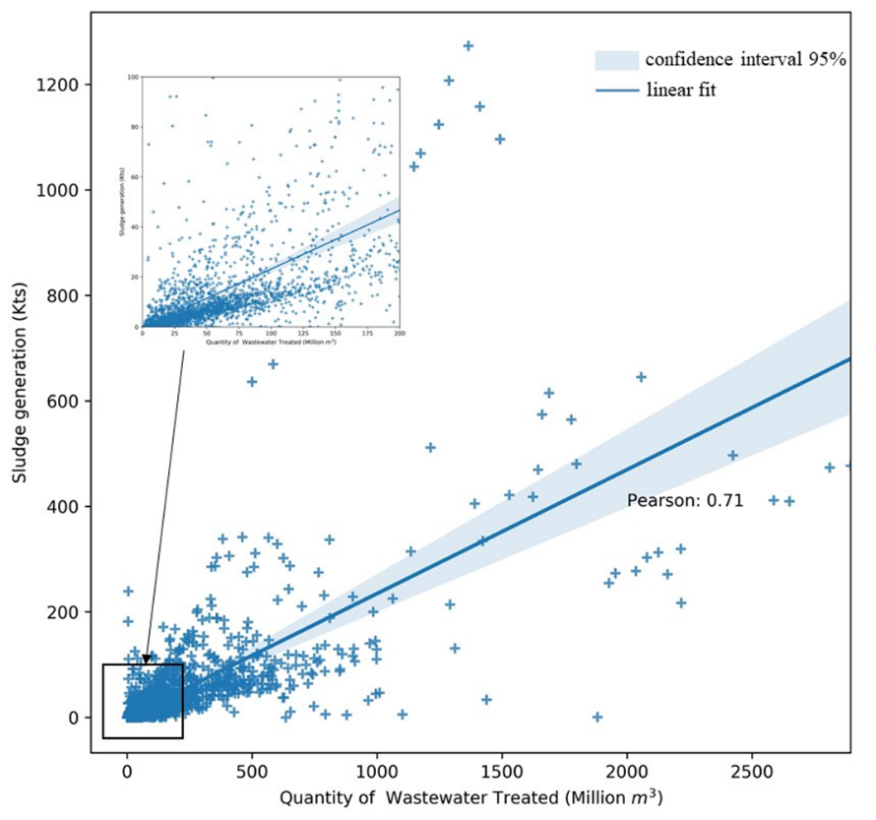

**Figure 2.** Correlation between sludge generation and the quantity of wastewater treated

**Table 1** Conversion coefficients in each province

|  |  |
| --- | --- |
| **Province** | **s (t/10 Kts)** |
| Beijing | 7.31 |
| Tianjin | 5.95 |
| Hebei | 8.26 |
| Shanxi | 7.51 |
| Inner Mongolia | 6.98 |
| Liaoning | 4.61 |
| Jilin | 4.13 |
| Heilongjiang | 5.60 |
| Shanghai | 4.56 |
| Jiangsu | 6.43 |
| Zhejiang | 9.95 |
| Anhui | 4.61 |
| Fujian | 4.01 |
| Jiangxi | 3.07 |
| Shandong | 7.85 |
| Henan | 6.55 |
| Hubei | 4.65 |
| Hunan | 3.29 |
| Guangdong | 4 |
| Guangxi | 3.37 |
| Hainan | 3.48 |
| Chongqing | 6.04 |
| Sichuan | 5.31 |
| Guizhou | 3.56 |
| Yunnan | 4.77 |
| Tibet | 2.27 |
| Shaanxi | 7.83 |
| Gansu | 9.92 |
| Qinghai | 6.22 |
| Ningxia | 7.55 |
| Xinjiang | 7.91 |

Historical socio-economic data were obtained from China City Statistical Yearbook (National Bureau of Statistics., 2020),. China's gross domestic product (GDP) and population projection in the framework of Shared Socioeconomic Pathways (SSPs) were provided by Prof. Jiang Tong at Nanjing University of Information Engineering. They projected China's GDP and population from 2020-2100 based on SSP1-SSP5 scenarios and Cobb-Douglas model (Jiang et al., 2017; Jiang et al., 2018).

## 2.2 Methods

In this study, we followed three steps to explore the driving factors of sludge generation in China and predict its future trends. In addition, GHG emissions potential of sludge process and disposal in future were calculated. First, we used a bottom-up collection of statistical data to account for the generation of dry sludge from urban wastewater treatment plants in China, we also used prefecture-level municipalities as the basic unit. Second, we explored the spatial distribution characteristics of sludge generation in China, combined various factors such as economic development, technological progress, urbanization, urban infrastructure construction level, residents' lifestyle, and natural conditions in China, establish a comprehensive index system of sludge driving factors, and quantitatively identify the driving factors of sludge generation using the Geodetector model.

Finally, we combined the global framework of IPCC Shared Socioeconomic Pathways SSP1-SSP5 with China's development characteristics, the quantitative relationship between sludge generation and each driving factor were obtained by using machine learning methods to construct a sludge generation regression model, discussing the height that sludge production will reach in each province of China under different development pathways and the challenges of its GHG potential for environmental adaptation and mitigation. In order to understand the sludge growth patterns in different regions, we use the K-means method to cluster the sludge growth rate with the annual sludge production and classify the future sludge growth patterns in China into four categories: high-value & high-growth, high-value & low-growth, low-value & high-growth, and low-value & low-growth.

### 2.2.1 Sludge Projection

Sludge generation from municipal wastewater treatment plants is mainly influenced by the economic level, industrial structure, social development, treatment technology, and food consumption structure. In this study, we selected 9 indicators to explore sludge driving factors (Table 2). The spatial variation of sludge generation in China is significant, and to explore the spatial heterogeneity of different sludge influencing factors and the degree of influence on sludge production, this paper introduces a Geodetector model to identify sludge driving factors. Factor detector is measured by q-statistics, the expression is shown as follows:

$q=1-\frac{\sum_{h=1}^{L}{N_{h}σ_{h}^{2}}}{Nσ^{2}}$（2）

Where $h=1,...,L$ is the strata of of $Y$ or $X$; $N$ and $N_{h}$ are the number of units of whole strata and stratum $h$ respectively; $σ^{2}$ and $σ_{h}^{2}$ are the variance in whole strata and stratum $h$ respectively. For $q∈[0,1]$, a higher value of q indicates a stronger spatially stratified heterogeneity of Y. The significance of q value was determined by F-test.

**Table. 2.** Indicator Description

|  |  |  |
| --- | --- | --- |
| **Classification** | **Indictor** | **Source** |
| Socioeconomic | Gross domestic products (GDP) | China City Statistical Yearbook |
| Population (POP) | China City Statistical Yearbook |
| Proportion of primary industry(PPI) | China City Statistical Yearbook |
| Urbanization rate (UR) | China Statistical Yearbook |
| Urban form | Length of drainage pipeline (LDP) | China City Statistical Yearbook |
| Built-up area (BA) | China City Statistical Yearbook |
| Lifestyle | Food consumption expenditure (FCE) | China City Statistical Yearbook |
| Carbon contents of food (CCF) | China City Statistical Yearbook |
| Technology | Reduction rate of COD (RCOD) | Urban Darainage Statistical Yearbook |

Sludge projection is a multivariable regression problem with sludge driving factors as the independent variables. We used Shared socioeconomic pathways and Logistic growth to fit the trends of sludge driving factors. The relationship between sludge generation and its driving factor were obtained by using Random Forest (RF). Random Forest Algorithm (RFA) is an Ensemble Learning algorithm based on Decision Tree, which has the advantages of high accuracy, robust to outliers and noise, and insensitive to overfit. Firstly, a number of sample datasets are randomly selected from the original dataset (the training dataset in this paper is the dataset of sludge generation and its driving factors in each province from 2006-2017, including the seven features). Second, other data also known as out of bag (OOB) were used as test set. We used sklearn to build the model and selected hyperparameters based on Grid Search. Bootstrapping were used to avoid overfit (Sumanta et al., 2018; Li et al., 2019). The accuracy of our model could reach up to 80.2% (MAPE) on our test set. Finally, we calculated the corresponding carbon emission of sludge disposal by multiply sludge generation and its conversion coefficients under different disposal methods.

### 2.2.2 Scenario analysis

Scenario analysis can help assess the environmental response to human activities and the effectiveness of different pollution management methods (Zhang et al., 2021). Shared Socioeconomic Pathways (SSPs) is one of the most widely used framework of scenario analysis proposed by IPCC. SSPs provide an overall framework for future socio-economic development, making it possible to compare the characteristics of sludge changes between different regions. The SSPs contains five types of social and economic development paths, SSP1(Sustainability)，SSP2（Middle of the road），SSP3（Regional Rivalry），SSP4(Inequality)，SSP5（Fossil-fueled development）(O’Neill et al., 2015). SSPs adopts multiple elements, including population, economy, technology, environment and resources to model the complexity of future sludge growth and the various socio-economic factors.

In this paper, the growth trend of the sludge driver is predicted by setting different parameters of the Logstic model, and the parameters under the five paths are shown in (Tab. 1.). The expression of Logistic growth are as follows

$P\left(t\right)=\frac{KP_{0}e^{rt}}{K+P_{0}\left(e^{rt}-1\right)}$（3）

Where *K* is the limit of growth, *P0*is the initial value (we used 2002 as the first year in this paper), *t* is the year, *r* is the growth rate. The *K* of BA, LDP, CCF, FCE, UR were all based on Logistic growth and Ordinary Least Square (OLS) to predict. According to the development trend of each province, we set the corresponding growth rate *r* with the growth inflection points around 2030, 2040, and 2050 (corresponding to Low, Medium, and High in the parameter settings, respectively, Table 3)

**Table. 3.** Overview of SSPs’ China’s characteristics.

|  |  |  |  |  |  |  |  |
| --- | --- | --- | --- | --- | --- | --- | --- |
|  | **GDP** | **BA** | **LDP** | **POP** | **CCF** | **FCE** | **UR** |
| SSP1 | Medium | Low | Low | Low | Low | Low | Low |
| SSP2 | Medium | Medium | Medium | Medium | Medium | Medium | Medium |
| SSP3 | Low | High | High | High | High | High | High |
| SSP4 | Medium | Medium | Medium | Low | Medium | Medium | Medium |
| SSP5 | High | High | High | Low | High | High | High |

# 3. Results and Discussion

## 3.1. Regional driving factors of sludge generation

The results of factor detection showed that all nine indicators passed the significance test at the 95% confidence level. BA and GDP have q-values of 0.654 and 0.638, respectively, and are the two most influential factors. The q-values of LDP (0.573), CCF (0.515), FCE (0.512),POP (0.501) are all above 0.500 and have a strong driving effect on sludge generation. Urban expansion leads to an increase in wastewater collection area, and economic and population growth leads to higher residential water consumption and more wastewater production, which in turn leads to higher sludge generation, which is the primary cause of sludge increment.

The q-values of both CCF and FCE were greater than 0.500, indicating a very close association between the resident’s dietary habits and sludge generation. At present, China is transitioning from a diet dominated by coarse grains and carbohydrates with minimal animal-source foods to one in which reﬁned rice and wheat and animal-source foods have increased signiﬁcantly and carbohydrates have declined (Li et al., 2016).. The decrease in the proportion of carbonated grains can reduce the carbon content of the population's food consumption and thus reduce sludge generation. China's food culture is diverse, regional food consumption habits vary greatly, and food carbon consumption is higher in the western region. According to the dietary structure guidelines recommended by the Residents' Diet Report, the Tibetan region is higher than the 60-100g daily carbon intake standard recommended by China's Residents' Diet Report. A shift from a high-carbon to a low-carbon diet can slow the sludge growth.

UR (0.263) and PPI (0.162) has relatively lower q-value, which has different mechanism with other indicators on sludge generation. The result is consistent with C007. RCOD indicates the level of wastewater treatment technology. However, compared with other factors, the effect of RCOD is miniscule (0.065). Chian has a certain number of WWTP which were operated with relatively advanced treatment technology. In these WWTPs, RCOD is relatively high, the improvement of technology has limited effect on sludge generation in future. As a result, we selected 7 factors which q-value were greater than 0.2 as the features of sludge projection.



**Figure.3.** Discretization methods and q-values of sludge driving factors.

## 3.2. Sludge generation in SSP1-SSP5 scenarios

Sludge generation under different SSP scenarios have similar growth trends (Figure.4.). All SSPs has a growing trends while the growth rate were decreased. SSP5 has the greatest sludge generation in 2060, which can up to 25.25Mt, SSP3 and SSP4 generates 24.19Mt and 23.13Mt sludge respectively. SSP1 and SSP2 has similar generation in 2060, generating 20.56Mt and 21.56Mt respectively. China’s total sludge generation in 2060 will reach up to 2 to 2.5 fold compared with 2017 which has 10.49Mt sludge generation. Importantly, SSP1 has the lowest growth that only 1.95 fold in 2060 to 2017 while SSP5 is has the highest growth that 2.41 fold. Under SSP1 scenario which have less sludge generation and lower sludge growth rate leads to a suitable development path for sludge mitigation.

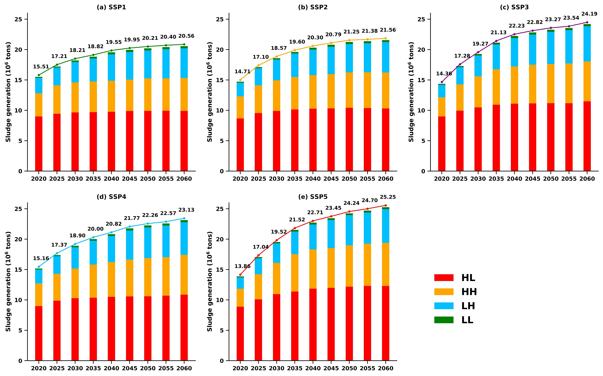

**Figure.4.** The trend of sludge generation under different scenarios.

To distinguish different growth pattern in different regions, we used K-means to cluster China’s province based on its sludge generation in 2060 and the ratio of sludge generation in 2060 to 2017 under different scenarios. In the future, the sludge growth pattern can be distinguished as four patterns (Figure.5), i.e. high generation and high growth (HH), high generation and low growth (HL), Low growth and high generation (LH), low generation and low growth (LL). Four representative provinces are shown yi the (Figure.6.). HL includes 11 provinces such as Guangdong, Jiangsu, Zhejiang and so on. These provinces are mainly distributed in eastern China. In 2017 these provinces contribute 78% of sludge generation in China while 48% in 2060. The contribution rate were decreased since the total generation in HL remains stable. However, these areas are still the most contributors in China and facing severe situation of sludge mitigation. Take Zhejiang province as an example, its sludge generation grows subtly under SSP3 and SSP5 and remains stable under other scenarios. Avoiding the path dominated by regional competition and fossil fuels can reduce sludge generation by 100 to 200Kts every year. Reducing the sludge generation from the end through technical means is an important tool for local sludge reduction due to its stable population and urbanization rate.



**Figure.5.** Sludge generation under SSP1-SSP5 scenarios in 2060 at provincial level

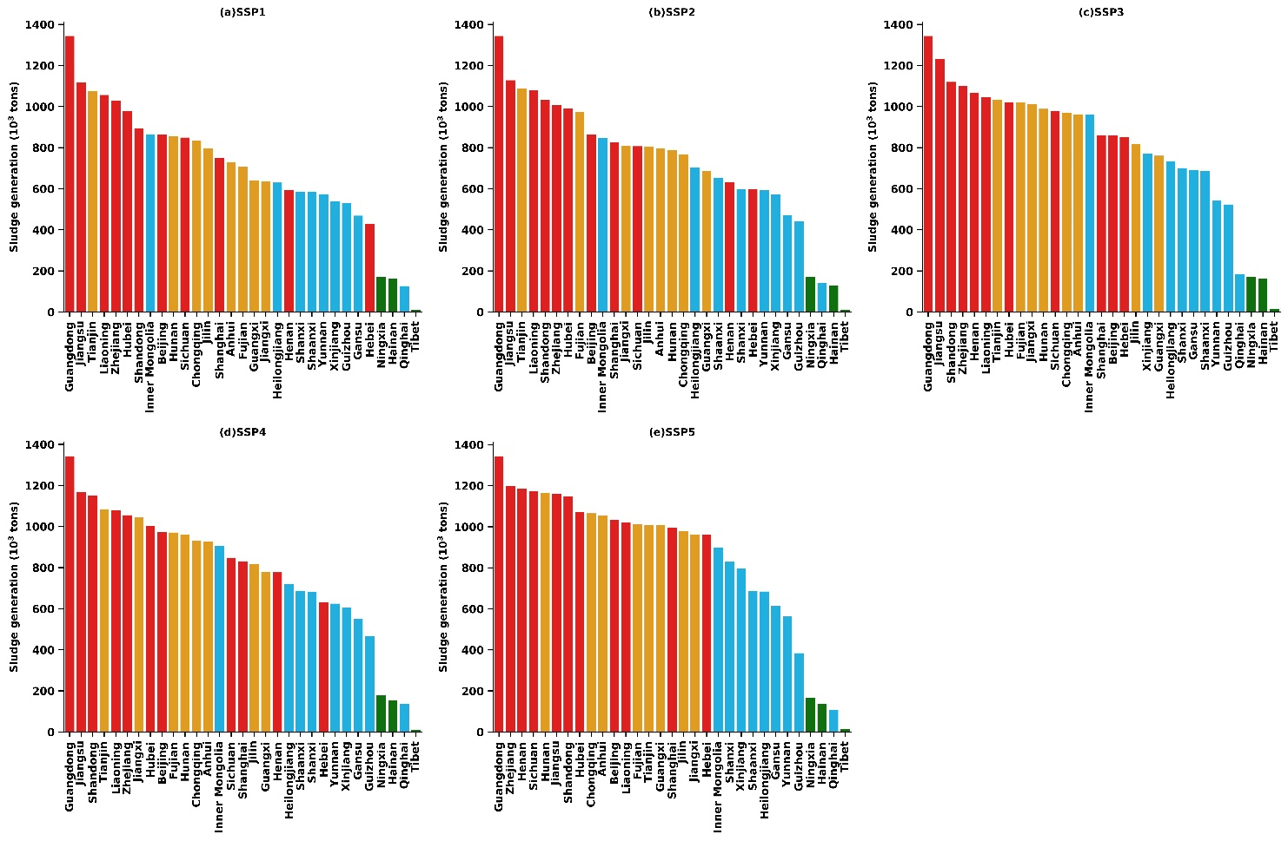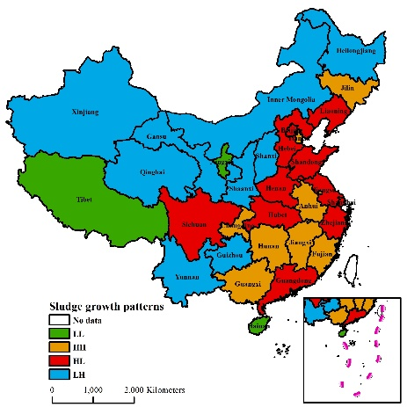

LH and HH are those provinces sludge increase rapidly. The two patterns’ contribution of sludge generation will increase from 10% and 9% to 24% and 26% in 2060 respectively. Most provinces in western and northern China shows this kind of trend. The great potential of these province leads to great potential of sludge growth. Guangxi and Gansu represent these trends. Under SSP3, SSP5 and SSP5, sludge grow rapidly after 2030 since the rapid growth of social economy and urbanization, which boost the generation of wastewater. The relatively high carbon content of food in the Midwest and the transition of residents' dietary habits to the recommended dietary structure can reduce the sludge load in wastewater from the source. Combined with the advancement of wastewater treatment technology level, forming a sludge reduction path from source to end is an important means to reverse the trend of rapid sludge growth.



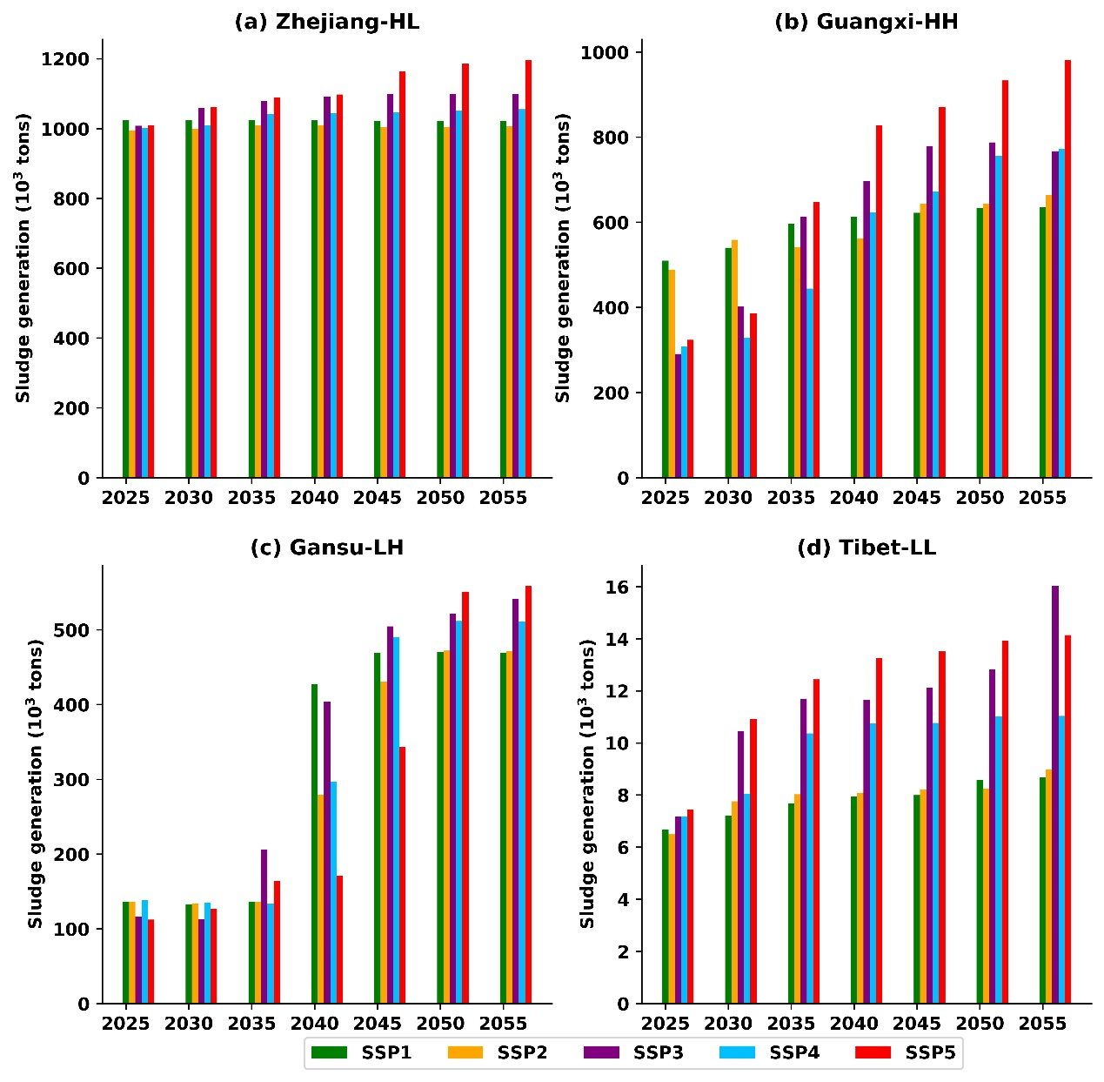LL includes Tibet, Ningxia and Hainan which have relatively lower sludge generation and growth rate have less tense of sludge mitigation. However, little development of sludge disposal methods in Tibet and Ningxia cause sludge disposal at will and simply Landfilling becomes the dominant disposal methods. Improving policy regulation, building high technology level centralized wastewater treatment facilities, and forming a comprehensive sludge regulation and disposal system is a reasonable direction for local development.

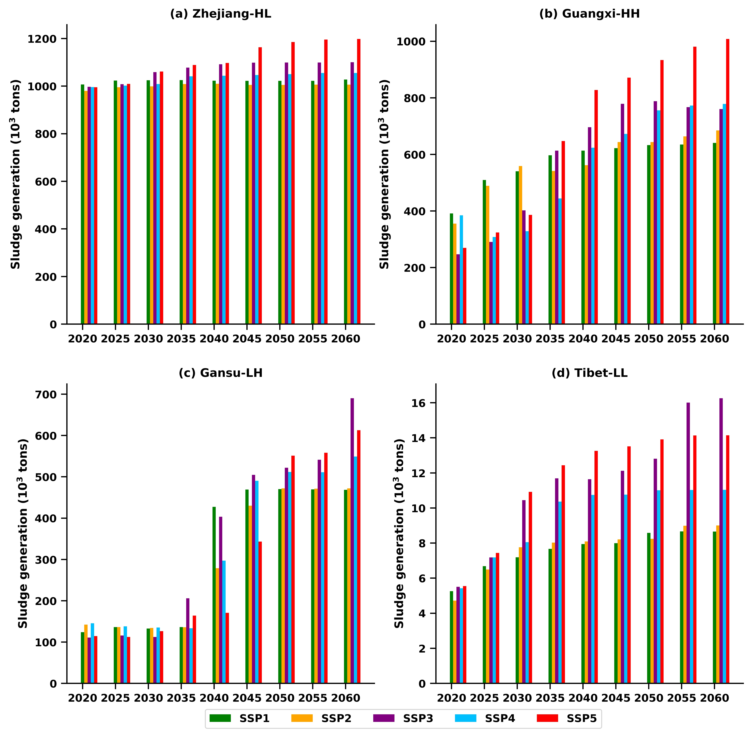

**Figure.6.** The trend of sludge generation under different scenarios of four representative province -- Zhejiang，Guangxi，Gansu and Tibet



## 3.3. Greenhouse gas emissions of sludge

In 2017, 29.67Mts CO2 would be released from sludge if they were treated without AD, which contributes 0.3% of the total CO2 emission in China. Landfill，incineration, land application and building material generated 9.68Mt,10.57Mt,1.25Mt, and 8.17Mt CO2 respectively. 9.67Mt CO2 would be released from sludge disposal if they were generated with AD and four disposal methods generate 2.76Mt, 7.23Mt, 0.86Mt, and 1.18Mt respectively. The total potential of greenhouse gas emission reduction (PGER) can reach up to 17.64Mt CO2, 6.92Mt, 3.34Mt, 0.39Mt, and 6.99Mt from respective disposal methods. AD contributes 59.5% GHG reduction from sludge treatment. At the provincial level, Guangdong, Zhejiang, and Jiangsu ranked top 3 of PGER, which are 3.45Mt，1.72Mt,and 1.61Mt respectively. Qinghai and Hainan are the lowest, only about 0.02Mt and 0.04Mt CO2 respectively. Other provinces ranged from 0.05 to 1.45Mt (Figure.6.).

**Figure.7.** Greenhouse gas emission from sludge disposals under different provinces in 2017.

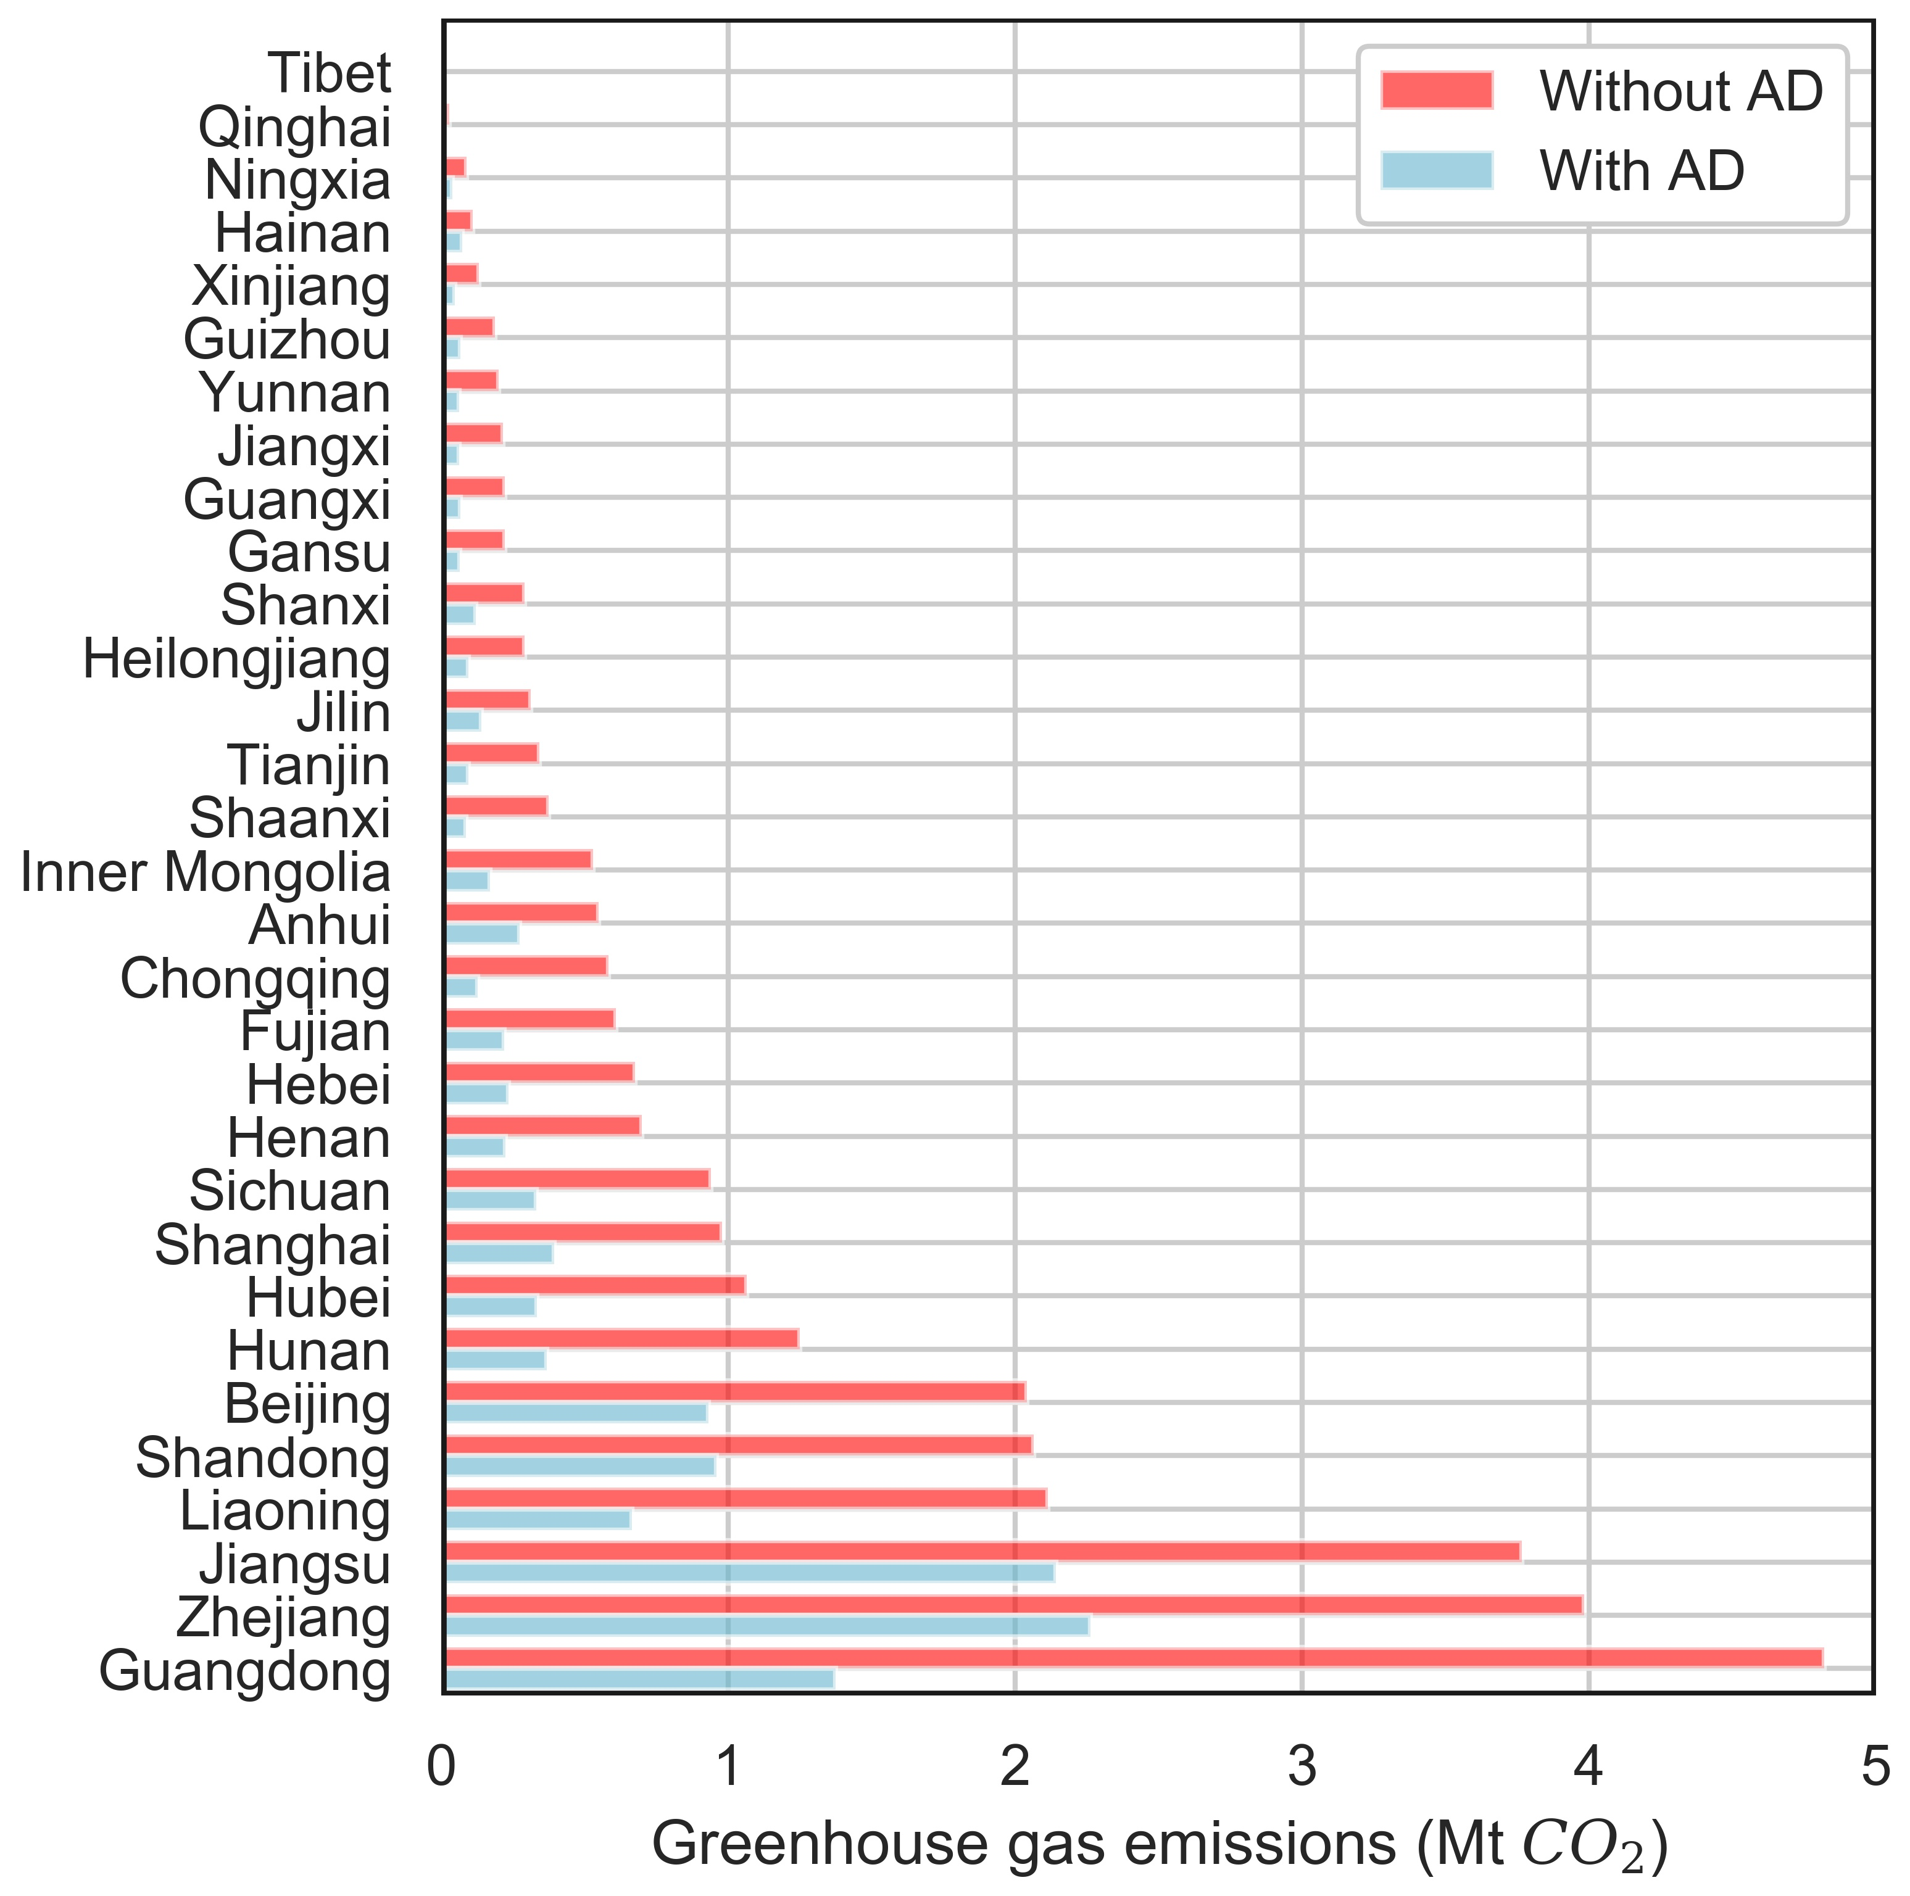

Figure 8 illustrates the GHG emissions from sludge treatment and disposal under the five SSP pathways. Under all five pathways, GHG emissions will increase in varying degrees, with growth rates ranging from 10% to 50%. The sludge disposal method is an important factor affecting the carbon emission of sludge, and the four common sludge disposal methods are Landfill, Incineration, Land application, and Building material. Landfill, not only consumes a large amount of land resources, but also has potential harm to groundwater and can affect human health. Therefore, this disposal method will be restricted in the future, Incineration will lead to a large amount of GHG emissions, but at present, about 15% of sludge is still treated and incinerated directly, which is an important source of carbon emissions from sludge. The use of sludge for building materials requires incineration treatment, which also has the disadvantage of wasting the chemical elements in sludge (Jin et al., 2014). Land development and utilization, such as composting, will be an important way of sludge resource utilization in the future, which can reduce carbon emissions from sludge disposal by more than 90% compared to sludge incineration.

Currently, these four methods account for about 55%, 15%, 20%, and 10% of sludge disposal in China respectively, with significant regional variations. LH, mainly in the central and western regions of China, the proportion of Landfill is 80%, and the phenomenon of sludge being discarded at will is widespread. As sludge generations rises, the backward sludge disposal process will aggravate the environmental hazards of sludge. The proportion of sludge incineration in the HH region is 20%, which will generate about 4-7 Mts CO2 per year. regions with a large proportion of Land application, such as Hainan Province, with a proportion of nearly 90%, are ideal for the future development of sludge disposal methods nationwide. If the future sludge disposal method in China is composed of 5%, 5%, 70%, 10% (The improved sludge disposal methods), the annual carbon emission from sludge will be reduced by 17.85, 18.19, 19.27, 18.61, 19.14Mts in five scenarios respectively by 2030. Meanwhile, AD, as a key technology in sludge disposal, can further reduce 10-13Mts CO2 emissions on the result of improving sludge disposal methods which is about 80% reduction compared with present sludge disposal. Increasing the proportion of Land application and popularizing AD technology are important paths for future sludge carbon reduction. This is especially true for areas where sludge production is difficult to reduce due to rapid economic development and rapid growth in water demand, mainly including HH, provinces with rapid sludge growth in LH.

To evaluate the potential of Greenhouse Gas Emission Reduction (PGER) when implementing Anaerobic digestion and improving sludge disposal methods. We defined another scenario called Low Carbon Disposal (LCD) scenario which assume all the sludge were treated with anaerobic digestion and improved sludge disposal methods (5%, 5%, 70%, 10% for Landfill, Incineration, Land application, and Building material respectively). Under the LCD scenario, the GHG emission were effectively reduced (Figure 7). The PGER were correlated to its total GHG emissions under different scenarios. From SSP1 to SSP5, the PGER were 44.38, 46.55, 50.58, 48.74, 52.30Mt respectively which was about 75% of its total GHG emissions of Origin scenario (Without anaerobic digestion and improved disposal methods.)

In summary, to control the growth of carbon emissions from sludge, the introduction of AD measures and changes in sludge emission measures are effective tools. Without any intervention, sludge carbon emissions will continue to grow from 2020-2060. The trend of sludge carbon emissions will slow down as AD technology becomes widespread, and sludge carbon emissions will be the same in 2060 as in 2017 when each of the four major regions reaches a different percent of AD implementation.

**Table. 4.** Prevalence of AD in 2055 when sludge carbon emissions are the same as in 2017 (no change in sludge disposal method)

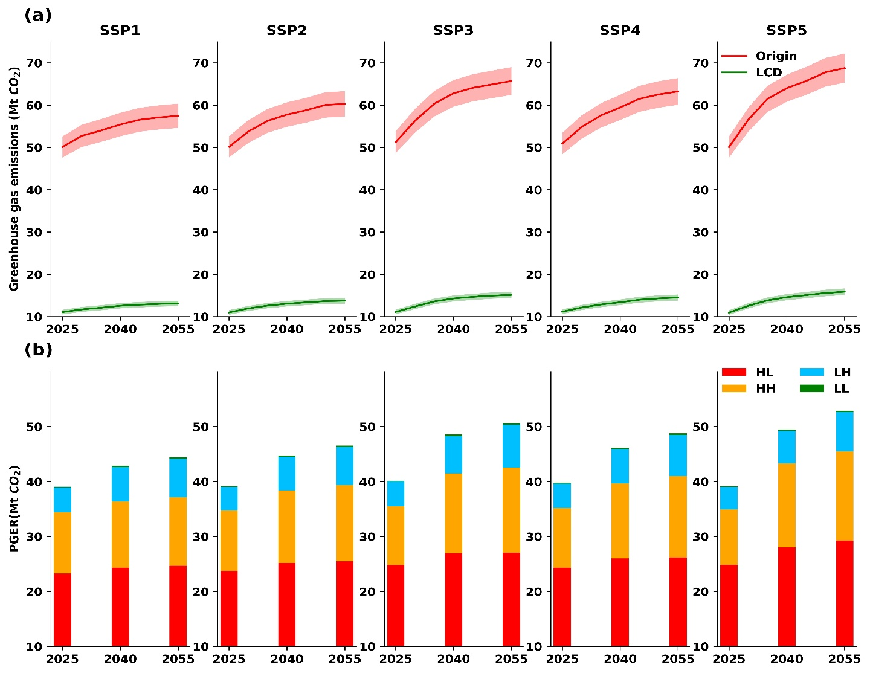

**Figure.8.** (a) Greenhouse gas emission from sludge disposals under different scenarios (Origin – Without Anaerobic digestion and improved disposal methods, LCD – low carbon disposal, 5% uncertainty were shown). (b) Potential GHG emission reduction in different area.

|  |  |  |  |  |
| --- | --- | --- | --- | --- |
|  | **HH(%)** | **HL(%)** | **LH(%)** | **LL(%)** |
| SSP1 | 18 | 41 | 67 | / |
| SSP2 | 29 | 55 | 79 | / |
| SSP3 | 38 | 74 | 92 | / |
| SSP4 | 30 | 64 | 91 | / |
| SSP5 | 44 | 84 | 96 | / |

## 3.4. Uncertainties

Projection analysis contains several difficult-to-quantify uncertainties. The uncertainties in sludge projection come from various aspects, such as simplifications of urbanization growth and city expansion. We used 5% to draw the uncertainty of our projection in figure 8.

There are uncertainties in the scenario results given that scenarios are based on a large number of assumptions about the future. Scenario results may be different if any of the hypotheses are changed, or even tweaked. However, a scenario projection is not a prediction; the goal of scenario analysis, as we understand it and have tried to employ it, is to provide a plausible glimpse of future socioeconomic conditions if stated assumptions hold. In other words, it is meant to be instructive and comparative, not predictive and absolute. In order to quantify the uncertainty of the prediction results, this paper takes the upper and lower 5% intervals for the predicted independent variables, respectively, to re-predict the sludge production. In SSP1 to SSP5 scenarios, SSP2 has the lowest variance while SSP4 has the greatest, which means SSP4 scenario has the greatest uncertainty of sludge growth in the future (Figure.9.).

**Figure.9.** Uncertainties of sludge prediction under different SSP scenarios.

# 4.Conclusions

To provide a picture of sludge generation and its GHG emission development in China, this paper expanded on existing research and forecasted the sludge generation of 30 provinces from 2018 to 2060. In this process, we used SSP and random forest to forecast sludge generation in China. The results of this paper provide more evidence for the development trends of sludge generation and its GHG emissions in China as a whole and in various regions and support relevant research in the future.

The main conclusions of this study can be drawn. (1) Under the SSP5 pathway, sludge production will reach 25.25 Mt in 2060, which is 2.45 times of that in 2017, and the resulting 70.04 Mt CO2 will intensify the pressure of carbon emission reduction. Relatively, under the SSP1 scenario, if the sludge is treated by AD, the carbon emission can be controlled at about 20Mt, which is most favorable to sludge and its carbon emission reduction. (2) Sludge growth trends in different regions of China can be divided into four patterns, with the central and western and northern regions having greater urbanization development potential and higher sludge growth rates. Combining low-carbon eating habits and improving wastewater treatment technologies to reduce sludge production and form a sludge reduction path from source to end is an important means to reverse the trend of rapid sludge growth. (3) Improving Land Application in sludge disposal and popularizing AD disposal technology (LCD scennario) are effective means of sludge carbon reduction, with a reduction potential of up to 50 Mt CO2 or more, and are important means of carbon reduction in areas where sludge reduction is difficult, such as areas with high economic development and rapid growth in water demand. (4) In order to reverse the increasing trend of sludge carbon emission, HH,HL,LH,LL will have different requirements on the penetration of local AD and improvement of sludge disposal, LL must improve the sludge disposal method to reduce carbon emission, while HH,HL,LH have higher requirements on the penetration of AD in order while the sludge disposal method remains unchanged.

参考文献

* 1. Andreoli C V，Fernandes F， Sperling M V，et al， Sludge Treatment and Disposal:Vol.6[J]，*Biological Wastewater Treatment*，2007.
  2. MOHURD, 2019. Chinese Statistical Yearbook of Urban and Rural Construction (In Chinese), http://www.mohurd.gov.cn/xytj/tjzljsxytjgb/jstjnj
  3. Eurostat，[https://ec.europa.eu/eurostat/data/database?node_code%C2%BCten00030[DB/OL](https://ec.europa.eu/eurostat/data/database?node_code%C2%BCten00030%5bDB/OL)]，2020.
  4. China Urban Water Supply and Drainage Association,2019.2018 Urban Drainage Statistical Yearbook: China Urban Water Association. (in Chinese)
  5. Second National Communication on Climate Change of the People’s Republic of China; Climate Change Division of National Development and Reform Commission of the People’s Republic of China, China Economic Press: Beijing, China, 2013.(in Chinese)
  6. Liangliang Wei, Fengyi Zhu, Qiaoyang Li, et al. Development, current state and future trends of sludge management in China: Based on exploratory data and CO 2 -equivaient emissions analysis. 2020, 144
  7. Yu, J.; Tian, N.; Wang, K.; Ren, Y. Analysis and discussion of sludge disposal and treatment of sewage treatment plants in China. Chin. J. Environ. Eng. 2007, 1, 5.
  8. Yong Geng，Meiling Wang，Joseph Sarkis，et al，Spatial-temporal patterns and driving factors for industrial wastewater emission in China[J]，*Journal of Cleaner Production*，2014，76.
  9. Yang Guang，Zhang Guangming，Wang Hongchen，Current state of sludge production， management， treatment and disposal in China[J]，*Water research*，2015， 78:60-73.
  10. Zhaofu Li，Hongyu Liu，Chuan Luo， et al，Industrial Wastewater Discharge Retrieval Based on Stable Nighttime Light Imagery in China from 1992 to 2010[J]，*Remote Sensing*，2014，6(8) : 7566-7579.
  11. Lili Ding，Zhanlei Lv，Meng Han，et al，Forecasting China's wastewater discharge using dynamic factors and mixed-frequency data[J]，*Environmental Pollution*，2019，255(Pt1).
  12. Elleuch Boubaker，Farah Bouhamed，Mabrouk Elloussa， et al，Environmental sustainability and pollution prevention[J]，*Environmental science and pollution research international*，2018，25(19):18223-18225.
  13. Tiziano Distefano，Scott Kelly，Are we in deep water? Water scarcity and its limits to economic growth[J]，*Ecological Economics*，2017，142:130-147.
  14. LiShan Xiao，Lin Chen，Shinichiro Nakamura，Tracing the consumption origins of wastewater and sludge for a Chinese city based on waste input-output analysis.[J]. Environmental science & technology， 2020.
  15. 王劲峰，徐成东.地理探测器:原理与展望[J].地理学报，2017，72(01):116-134. (in Chinese)
  16. Duarte，Pinilla，Serrano，Looking backward to look forward: water use and economic growth from a long-term perspective[J]，*Applied Economic，*2014，46(2).
  17. Kangkang Gu，Jingshuang Liu，Yang Wang，et al，Relationship Between Economic Growth and Water Environmental Quality of Anshan City in Northeast China[J]，*Chinese Geographical Science*，2009，19(01):17-24.
  18. Lingyun Jin，Guangming Zhang，Huifang Tian. Current state of sewage treatment in China[J]， *Water Research*，2014，66.
  19. Brian C. O’Neill， The roads ahead: Narratives for shared socioeconomic pathways describing world futures in the 21st century[J]，*Global Environmental Change*，2015.
  20. Zhang Xiaoxin et al. Modelling phosphorus loading to the largest shallow lake in northern China in different shared socioeconomic pathways[J]. Journal of Cleaner Production, 2021, 297
  21. P.J.T.M. van Puijenbroek and A.H.W. Beusen and A.F. Bouwman. Global nitrogen and phosphorus in urban waste water based on the Shared Socio-economic pathways[J]. Journal of Environmental Management, 2019, 231 : 446-456.
  22. Detlef P. van Vuuren,Marcel T.J. Kok,Bastien Girod,Paul L. Lucas,Bert de Vries. Scenarios in Global Environmental Assessments: Key characteristics and lessons for future use[J]. Global Environmental Change,2012,22(4).
  23. Elmar Kriegler et al. The need for and use of socio-economic scenarios for climate change analysis: A new approach based on shared socio-economic pathways[J]. Global Environmental Change, 2012, 22(4) : 807-822.
  24. Xu Xiaocong and Zhang Yuanying and Chen Yimin. Projecting China's future water footprint under the shared socio-economic pathways[J]. Journal of Environmental Management, 2020, 260
  25. Da Zhang et al. Impacts of urban expansion on ecosystem services in the Beijing-Tianjin-Hebei urban agglomeration, China: A scenario analysis based on the Shared Socioeconomic Pathways[J]. Resources, Conservation & Recycling, 2017, 125 : 115-130.
  26. Zhang Xiaoxin et al. Modelling phosphorus loading to the largest shallow lake in northern China in different shared socioeconomic pathways[J]. Journal of Cleaner Production, 2021, 297.
  27. Yuli Shan et al. New provincial CO2 emission inventories in China based on apparent energy consumption data and updated emission factors[J]. Applied Energy, 2016, 184 : 742-750.
  28. Rina Wu et al. Geographical Detector Model for Influencing Factors of Industrial Sector Carbon Dioxide Emissions in Inner Mongolia, China[J]. Sustainability, 2016, 8(2)
  29. Jin-Feng Wang et al. Geographical Detectors-Based Health Risk Assessment and its Application in the Neural Tube Defects Study of the Heshun Region, China[J]. International Journal of Geographical Information Science, 2010, 24(1) : 107-127.
  30. Jin-Feng Wang and Tong-Lin Zhang and Bo-Jie Fu. A measure of spatial stratified heterogeneity[J]. Ecological Indicators, 2016, 67 : 250-256.
  31. Wei Luo et al. Spatial association between dissection density and environmental factors over the entire conterminous United States[J]. Geophysical Research Letters, 2016, 43(2) : 692-700.
  32. Huang Jixia et al. Identification of health risks of hand, foot and mouth disease in China using the geographical detector technique.[J]. International journal of environmental research and public health, 2014, 11(3) : 3407-23.
  33. Chunyan Chai et al. Carbon Footprint Analyses of Mainstream Wastewater Treatment Technologies under Different Sludge Treatment Scenarios in China[J]. Water, 2015, 7(3) : 918-938.
  34. Yan Ru Fang et al. Spatio-temporal distribution of sewage sludge, its methane production potential, and a greenhouse gas emissions analysis[J]. Journal of Cleaner Production, 2019, 238
  35. Xu, Y., et al., Optimizing sampling strategy for Chinese National Sewage Sludge Survey (CNSSS) based on urban agglomeration, wastewater treatment process, and treatment capacity. Science of The Total Environment, 2019. 696: p. 133998.
  36. 潘金玉. 共享社会经济路径下中国经济发展趋势及影响要素研究[D].南京信息工程大学,2020.
  37. 姜彤,赵晶,景丞,曹丽格,王艳君,孙赫敏,王安乾,黄金龙,苏布达,王润.IPCC共享社会经济路径下中国和分省人口变化预估[J].气候变化研究进展,2017,13(02):128-137.
  38. 姜彤,赵晶,曹丽格,王艳君,苏布达,景丞,王润,高超.共享社会经济路径下中国及分省经济变化预测[J].气候变化研究进展,2018,14(01):50-58.
  39. Science， Researchers from University of Aegean Discuss Findings in Applied Geoscience (Urban land cover thematic disaggregation， employing datasets from multiple sources and RandomForests modeling)[J]， Science Letter， 2016.
  40. Yu Fubo et al. Deep exploration of random forest model boosts the interpretability of machine learning studies of complicated immune responses and lung burden of nanoparticles.[J]. Science advances, 2021, 7(22)
  41. L.Breiman, Random forests[M]. Mach. Learn.45,5-32(2001)
  42. Basu Sumanta et al. Iterative random forests to discover predictive and stable high-order interactions.[J]. Proceedings of the National Academy of Sciences of the United States of America, 2018, 115(8) : 1943-1948.
  43. Bo Li et al. Robust dimensionality reduction via feature space to feature space distance metric learning[J]. Neural Networks, 2019.
  44. 郑新奇，薛春璐，王伟等.中国城市用地增长极限规模测算[J]，中国人口资源与环境，2013，23(08):55-61.
  45. Lu Lu et al. Wastewater treatment for carbon capture and utilization[J]. Nature Sustainability, 2018, 1(12) : 750-758.
  46. Guo Hao nan et al. Application of machine learning methods for the prediction of organic solid waste treatment and recycling processes: A review[J]. Bioresource Technology, 2021, 319 : 124114-.
  47. McCarty P L, Bae J, Kim J. Domestic wastewater treatment as a net energy producer–can this be achieved? Environmental Science and Technology.2011, 45, 7100–7106
  48. Huimin Li,Tong Wu,Xiao Wang,Ye Qi. The Greenhouse Gas Footprint of China's Food System: An Analysis of Recent Trends and Future Scenarios[J]. Journal of Industrial Ecology,2016,20(4):
  49. Guo Hao nan et al. Application of machine learning methods for the prediction of organic solid waste treatment and recycling processes: A review[J]. Bioresource Technology, 2021, 319 : 124114-.
  50. Kannangara, M., Dua, R., Ahmadi, L., Bensebaa, F., 2018. Modeling and prediction of regional municipal solid waste generation and diversion in Canada using machine learning approaches. Waste Manage. 74, 3–15.
  51. Younes, M.K., Nopiah, Z.M., Basri, N.E.A., Basri, H., Abushammala, M.F.M., Maulud, K.N.A., 2015. Prediction of municipal solid waste generation using nonlinear auto- regressive network. Environ. Monit. Assess. 187, 753.
  52. Abbasi, M., Abduli, M.A., Omidvar, B., Baghvand, A., 2013. Forecasting municipal solid waste generation by hybrid support vector machine and partial least square model. Int. J. Environ. Res. 7, 27–38.
  53. Kumar, A., Samadder, S.R., Kumar, N., Singh, C., 2018. Estimation of the generation rate of different types of plastic wastes and possible revenue recovery from informal re- cycling. Waste Manage. 79, 781–790.